EX:NO:08 SOFTWARE PERSONNEL MANAGEMENT SYSTEM
1.USECASE DIAGRAM:
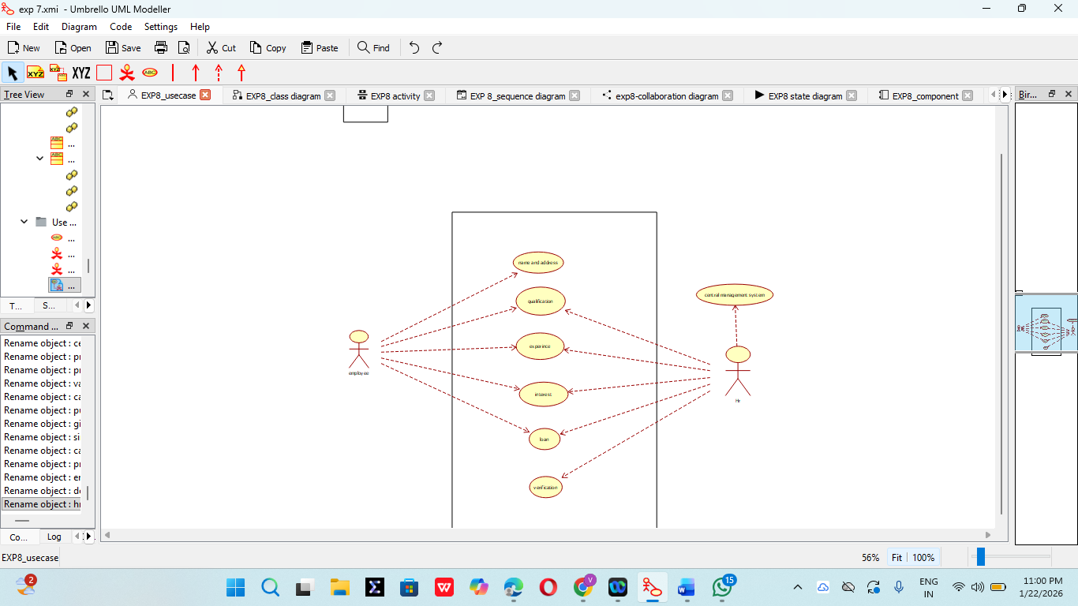

2. CLASS DIAGRAM:
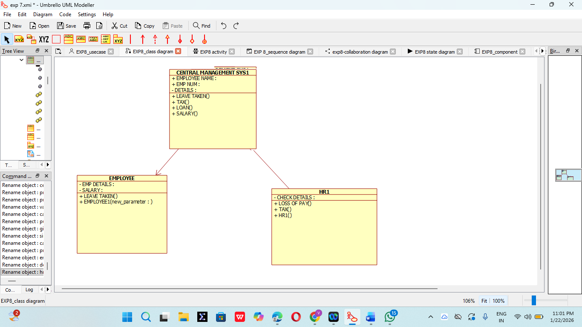
3. ACTIVITY DIAGRAM:
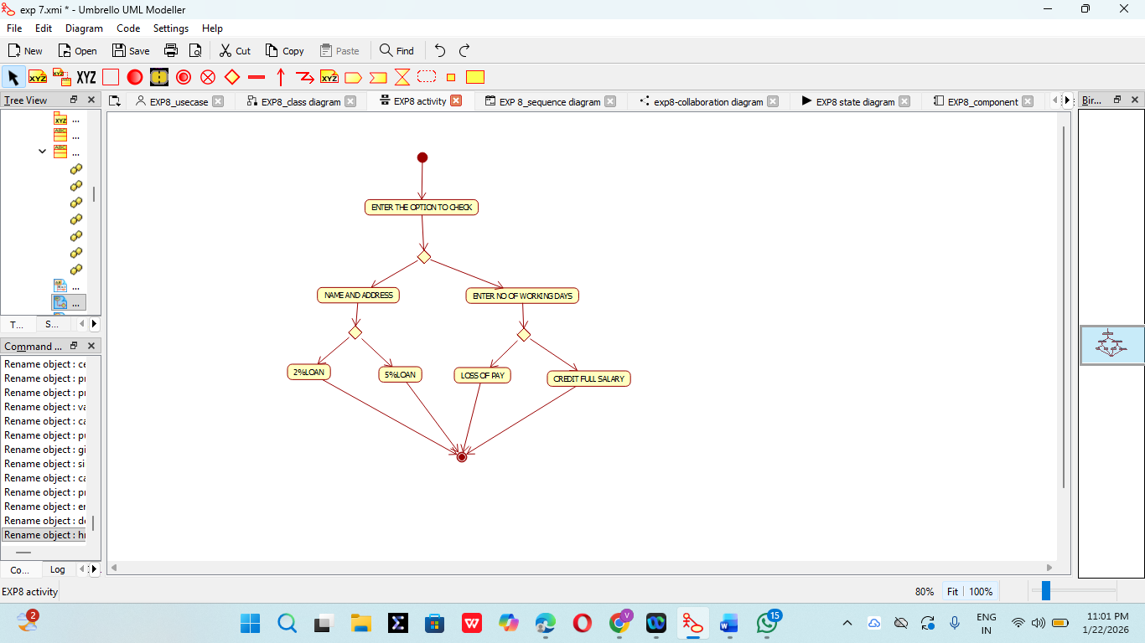

4. SEQUENCE DIAGRAM:
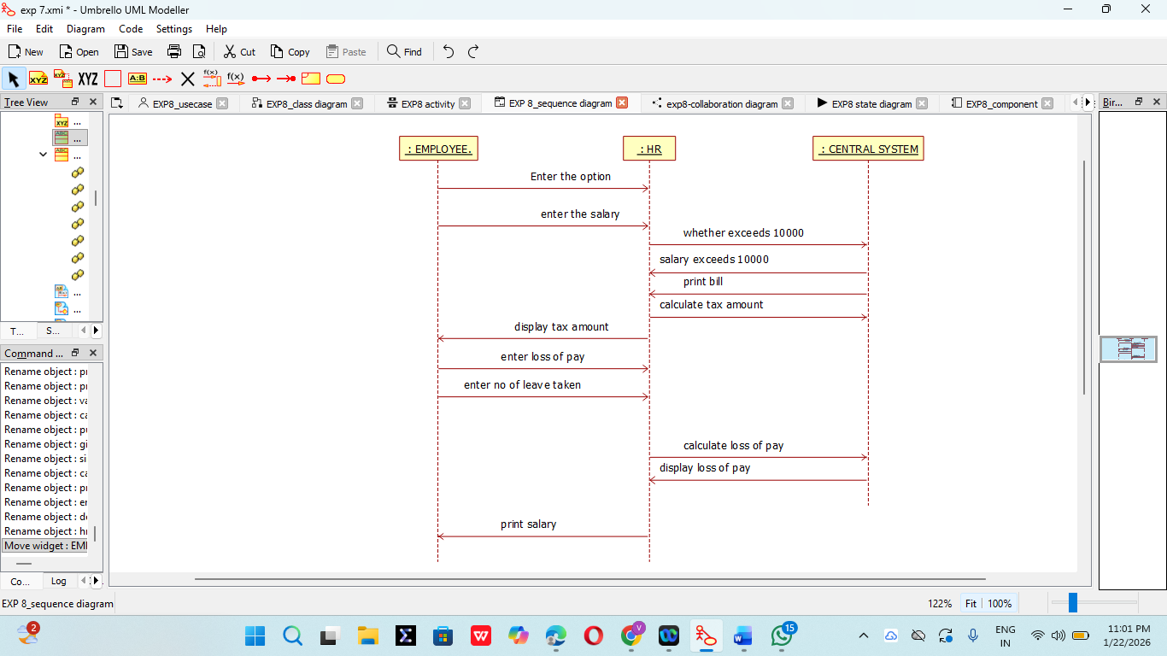

5. COLLABORATION DIAGRAM:
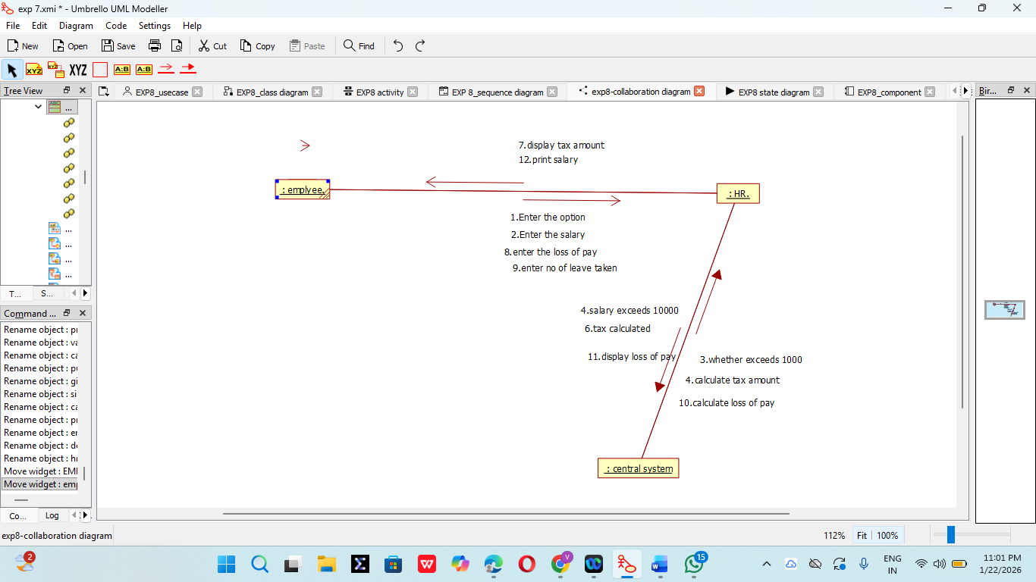
6. STATE CHART DIAGRAM:
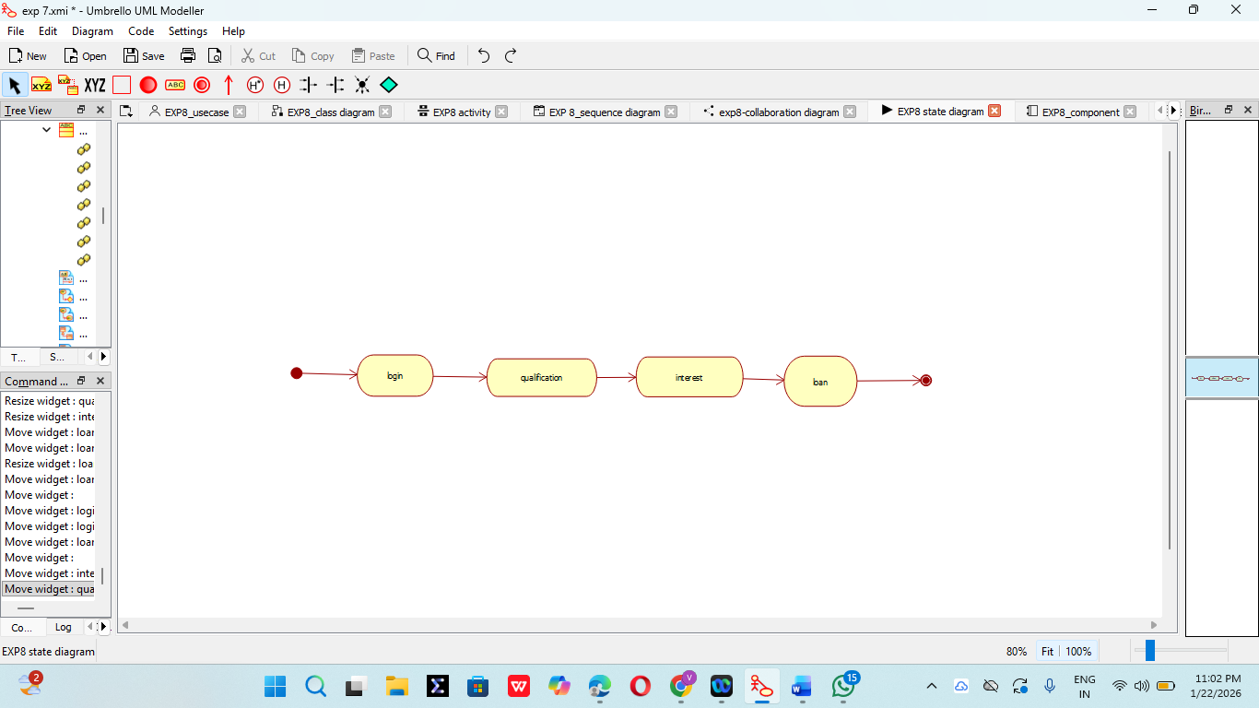

7. COMPONENT DIAGRAM:

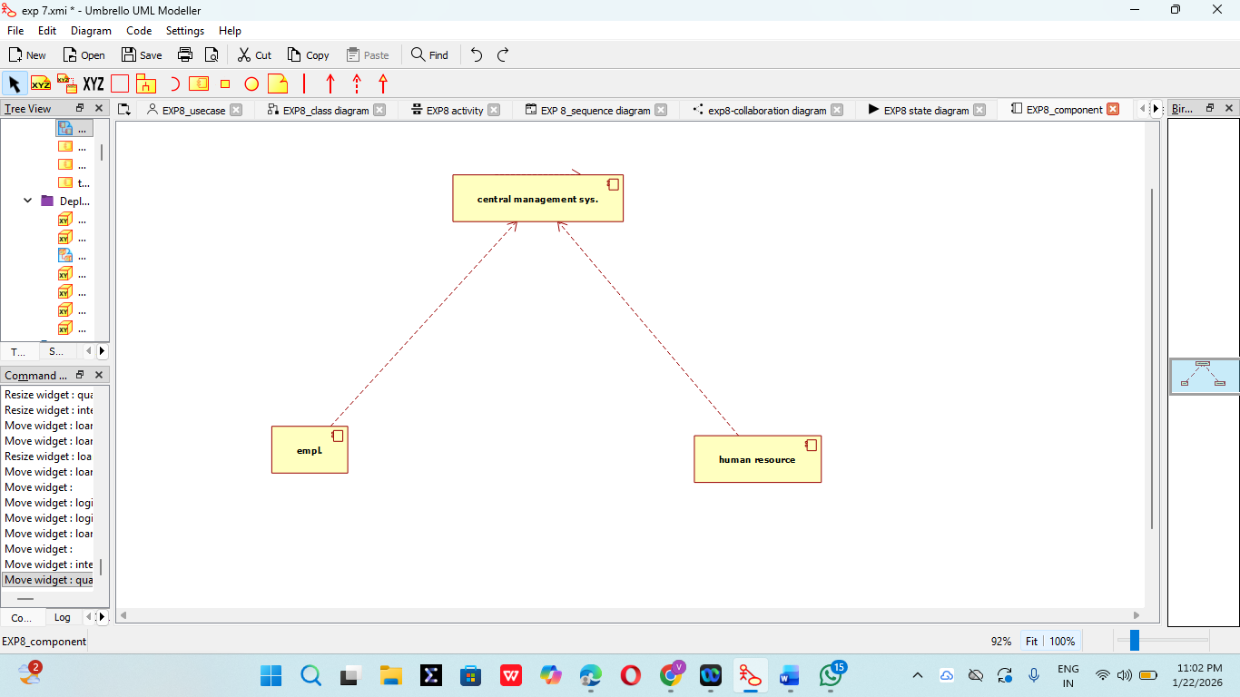
8. DEPLOYMENT DIAGRAM:

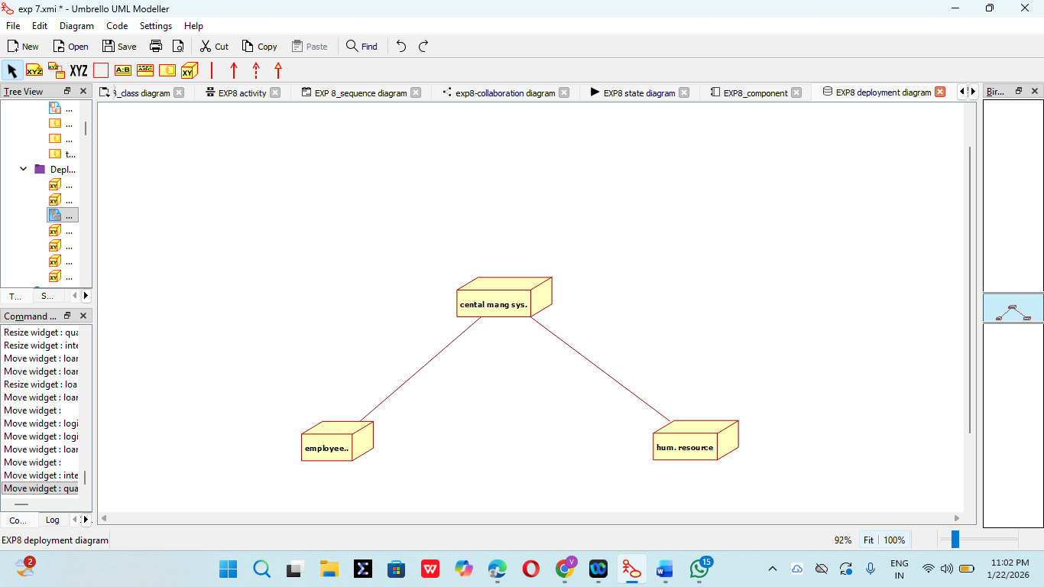
9. PACKAGE DIAGRAM:

